- Create a table listing 3 types of printers, 2 types of scanners, and 2 types of webcams, and for each, write one real-life use case (for example: 'Inkjet printer – printing college assignments').

Device Type | Type | Real-Life Use Case
Printer | Inkjet Printer | Printing college assignments and color photos
Printer | Laser Printer | Printing office documents and reports quickly
Printer | 3D Printer | Creating 3D models and prototype parts
Scanner | Flatbed Scanner | Scanning documents, certificates, and photos
Scanner | Sheet-fed Scanner | Scanning multiple pages of office documents
Webcam | Built-in Webcam | Attending online classes or video calls
Webcam | External USB Webcam | Streaming games or recording videos

- Draw a labeled diagram showing how a typical home printer connects to a laptop or PC, including the connection interface used (USB, Wi-Fi, or Bluetooth).

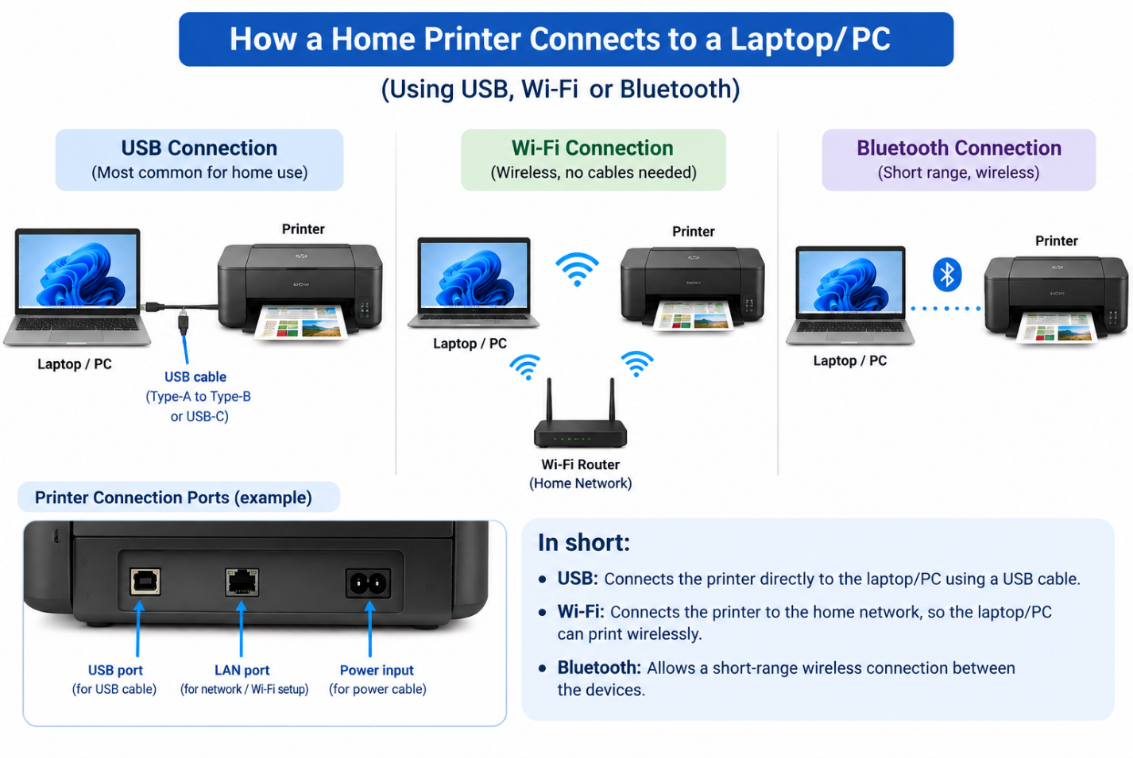
A typical home printer can connect to a laptop or PC using USB, Wi-Fi, or Bluetooth.
With USB, a cable directly connects the printer to the computer.
With Wi-Fi, both devices connect through the same wireless network, while Bluetooth provides a short-range wireless connection.

- List three different connection interfaces (such as USB, Wi-Fi, Bluetooth) used by peripherals like printers, scanners, and webcams, and for each, name one advantage and one disadvantage.Think about speed, convenience, and compatibility

USB: USB is a fast and reliable connection commonly used for printers, scanners, and webcams. Its main advantage is good speed and wide compatibility with computers, but its disadvantage is that it requires a physical cable.
Wi-Fi: Wi-Fi allows peripherals such as printers and scanners to connect wirelessly to a computer through a network. It is convenient because there are no cables, but its speed and reliability can depend on the network connection.
Bluetooth: Bluetooth provides a convenient short-range wireless connection for some peripherals. It is easy to use without cables, but it is generally slower than USB and may not be supported by every peripheral.

- pick any one device you use at home or college (printer, scanner, or webcam). Write step-by-step instructions for how you would connect it to your computer, including what cable or wireless method you would use and any setup steps required.
Connecting a Printer to a Computer
Step 1: Turn on the printer and make sure it has paper and ink/toner.
Step 2: Connect the printer to the computer using a USB cable.
Step 3: Connect the printer’s power cable and switch it on.
Step 4: Wait for the computer to detect the printer automatically.
Step 5: If required, install the printer driver or software provided by the manufacturer.
Step 6: Open Settings → Bluetooth & devices → Printers & scanners and check that the printer is listed.
Step 7: Select the printer and print a test page to confirm that the connection is working.

